**Implementation of Gabor filters and its applications for emotion detection**

***Report of IVP Project***

*FOR THE DEGREE OF*

**BACHELOR OF TECHNOLOGY**

***IN***

**INFORMATION TECHNOLOGY**



*BY*

Mohneesh Khaneja (IIT2014041)

Prateek Agarwal (IIT2014068)

Shivam (IIT2014077)

Pratik Mangalore (IIT2014112)

*UNDER THE SUPERVISION OF*

Professor. ANUPAM AGRAWAL

IIIT-ALLAHABAD

**INDIAN INSTITUTE OF INFORMATION TECHNOLOGY, ALLAHABAD**

March 2017

**ABSTRACT**

The human face plays an important role in the field of automatic recognition of emotion and interaction between human and computers.

Feature Extraction from the human face is an important step in emotion recognition . Various techniques have been used to extract features such as eyes, nose, lips and more from the human face in the recent times. Here Gabor Filter with changing parameters is being used to extract not only features but also the various forms these features can take when displaying emotions - Tilted eyebrows when expressing anger or sadness.

To detect the emotions, facial attributes are extracted using dimensionality reduction and convoluting the images with a variety of Gabor filters. Finally to determine facial expressions separately, the processed feature vector is channeled through the already learned pattern classifiers.

**CANDIDATE'S’ DECLARATION**

We hereby declare that the work presented in this project report entitled “**Implement Gabor filters and its applications for emotion detection**”, submitted as report of IVP Project (Sem VI) at Indian Institute of Information Technology, Allahabad, is an authenticated record of our original work carried out from January 2017 to March 2016 under the guidance of **Prof. Anupam Agrawal**. Due acknowledgements have been made in the text to all other material used. The project was done in full compliance with the require

ments and constraints of the prescribed curriculum.

Place: Allahabad

Date: 20.03.2017

Mohneesh Khaneja (IIT2014041)

Prateek Agarwal (IIT2014068)

Shivam (IIT2014077)

Pratik Mangalore (IIT2014112)



**CERTIFICATE**

This is to certify that the above statement made by candidates is correct to the best of my knowledge.

Date: 20.03.2017 Prof. Anupam Agarwal

Place: Allahabad IIIT-Allahabad

**Table of Contents**

1. Introduction

2. Problem definition and objective

3. Literature Survey

4. Proposed Approach

5. Hardware and Software Requirements

6. Activity Time Chart

7. Experimental Setup and Results

8. Performance Comparison

9. Conclusion

10. References

**1.) Introduction**

One of the fundamental challenges in the recent times is that of an computer being able to recognize the emotion a human face has currently. This has necessitated the need of accurate and efficient automatic emotion recognition systems.

Based on the facial attributes the facial emotion can be classified into one of the six fundamental expression :

* Sadness
* Disgust
* Anger
* Happiness
* Fear
* Surprise.

We can also add “No emotion” to the above list to express the same state of the face.

Initially face extraction is performed in order to reduce the dimensionality of the training data. Then, we apply the Gabor Filter onto these reduced images in order to extract features which constitute the emotions. Finally the KNN Algorithm is utilized in order to classify the test image into an emotion.

**2). Problem definition and objectives:**

The main objective of this project is to classify the human faces based on their facial expressions which basically convey emotions. To do so we used Gabor Filter to extract features and supervised machine learning algorithm to classify.

We have considered seven classes with each class representing an emotion. Initially we have taken 5 fold crossover which is a classification technique that involves us splitting the dataset into 5 regions where each region is taken as the test data, other regions being training data, and this is repeated for every region. Gabor filter is applied to each of the training folds and we generate 80 features which in total occupy 213*768 bytes of memory . Then using KNN we classified the test data into one of the seven classes.

**3. Literature Survey**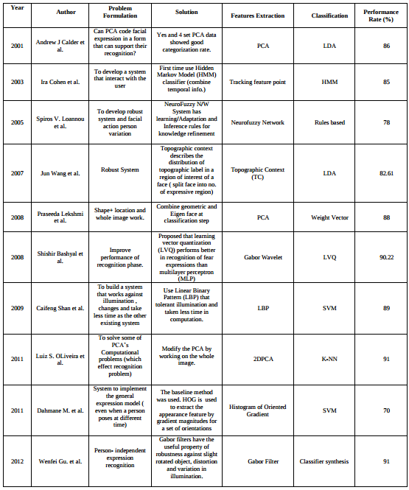

**4.) Proposed Approach**

The methodology of the whole application is subdivided into 3 broad and independent modules as described below:-

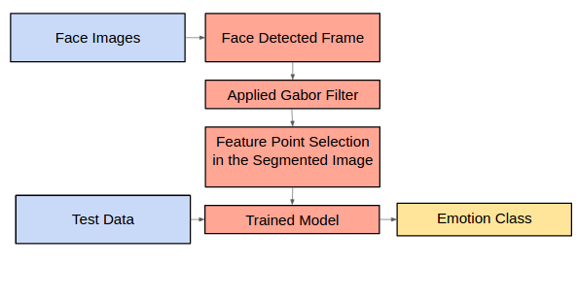

**4.1 Feature Extraction**

111.png

Gabor Filter was used to extract feature map for every image by varying the parameters such as lambda , theta , sigma , gamma psi and so for every given image 80 Responses were collected which in aggregation acted as a single feature map. These 80 responses were collected by varying theta across 16 values and lambda (wavelength) across 5 values.

The intuition behind the same is explained below:-

* **Theta** is the most important attribute passed to the gabor filter constructing function. Whenever we express our emotions our eyebrows, eyes and lips tilt at certain angles, where higher tilt angles usually denotes a more intense emotion. Each of the theta passed to the function captures a certain intensity of the emotion and hence we have taken 16 possible values of theta in order to obtain a good balance of depth and contrast in images.
* **Lambda** basically tells us the wavelength of the sinusoidal wave which is convolved with the gaussian function to ultimately create the gabor filter. Higher the value of lambda, less will be the effect of the sinusoid on the gaussian and hence the gabor filter will be smoother and the response with the image will also have less contrast. Lower values of lambda will capture even subtle changes in the image, such as brow furrows and shadows.
* **Gamma** controls the ellipticity of the gaussian. When gamma = 1, the gaussian envelope is circular.
* **Psi** controls the phase offset of the sinusoidal wave.

**4.2 Dimensionality Reduction**

Since for every image 80 Responses were collected and every image was of the size 256 * 256 , the feature map was of huge size. Therefore dimensionality reduction was done by extracting only the face out of the images. This effectively sped up the process by approximately 4 times and also reduced the space complexity by about half.

**4.3 Finding Emotion by Classifying the Images**

Once the dimensionality reduced feature maps are obtained , these are used to train the model for all the emotions present in the images and map a label for every given face image. We have used KNN classifier from weka to do the same.

P**5.) Hardware and Software requirements:**

* 1 GB RAM
* Python
* OpenCV
* Weka
* MatplotLib
* SciPy
* Scikit-Learn
* Numpy

**6. Activity Time Chart**

|  |  |  |  |  |
| --- | --- | --- | --- | --- |
|  | Before Mid-Sem | | After Mid-Sem | |
|  | Phase-I  1 Mar - 8 Mar | Phase-II  9 Mar - 16 Mar | Phase-III  17 Mar - 24 Mar | Phase-IV  25 Mar - 31 Mar |
| LITERATURE SURVEY | Done |  |  |  |
| PROBLEM IDENTIFICATION | Done |  |  |  |
| IDENTIFY AN APPROACH |  | Done |  |  |
| FACE DETECTION |  | Done |  |  |
| IMAGE FILTERING |  |  | Done |  |
| FEATURE POINTS SELECTION |  |  | Done |  |
| CREATING FEATURED DATA |  |  |  | Done |
| CLASSIFICATION |  |  |  | Done |

**7.Experiment Setup and Results**

**Experimental Setup:**

* We used **OpenCV** for performing basic image processing tasks such as extraction of face from given image, cropping the image.
* We used **Matplotlib** for analysing the image , viewing coordinates and indexes on the images.
* **SciPy** is an open source Python library used for scientific computing and technical computing. SciPy contains modules for optimization, linear algebra, integration, interpolation, special functions, FFT, signal and image processing, ODE solvers and other tasks common in science and engineering.
* **NumPy** is a library for the Python programming language, adding support for large, multidimensional arrays and matrices, along with a large collection of high-level mathematical functions to operate on these arrays.
* **Scikit-learn** is a free software machine learning library for the Python programming language. It features various classification, regression and clustering algorithms including support vector machines, random forests, gradient boosting, *k*-means and DBSCAN, and is designed to interoperate with the Python numerical and scientific libraries NumPy and SciPy.
* Weka contains a collection of visualization tools and algorithms for data analysis and predictive modeling, together with graphical user interfaces for easy access to these functions.

**Results:**

* This is the result of extracting the face from the image. This reduced our running time by a factor of 4 and our space complexity by an approximate factor of 2.

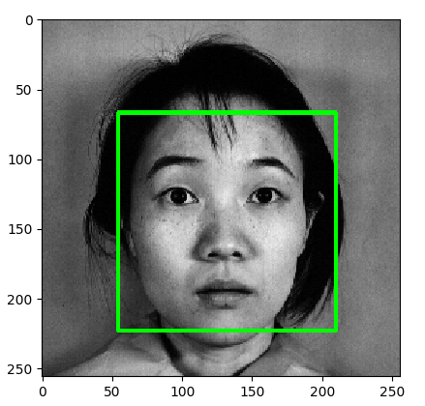

* These are few of the gabor kernels we have used to capture the facial features. The variations in theta can be easily seen from the below picture. The lower row also contains higher wavelength values. As one increases the wavelength the response becomes weaker and smoother.

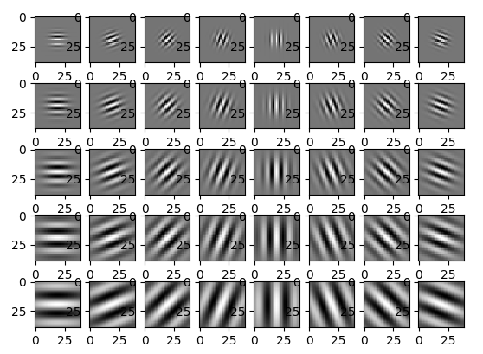

* This is the results window as displayed by WEKA GUI. Important things to note from here is the number of correctly - 83.56% and incorrectly classified instances - 16.44%, which give us the accuracy of our project. The confusion matrix tells us the number of ‘hits’ and ‘misses’ for each test image.

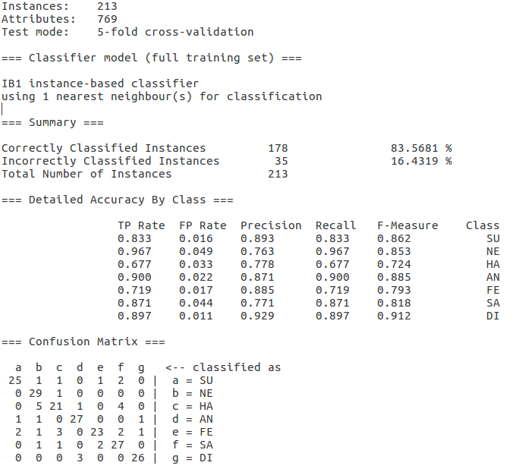

**8.Performance Comparison**

**K-Nearest Neighbors**

Correctly Classified Instances 178 83.5681 %

Incorrectly Classified Instances 35 16.4319 %

**RandomForest**

Correctly Classified Instances 150 70.4225 %

Incorrectly Classified Instances 63 29.5775 %

**Support Vector Machine**

Correctly Classified Instances 159 74.6479 %

Incorrectly Classified Instances 54 25.3521 %

**9.Conclusion**

Till today all of the existing vision system for facial muscle action detection deal only with the frontal-view face images and cannot handle the temporal dynamics of facial actions. However, with this shortcoming we have shown based on experimental confirmation that the proposed framework for automatic emotion detection can be well appertained to real time facial expression and emotion characterization task. Also for some human beings, they don’t show their emotion and mental states by facial expressions, for this kind of situation our proposed model significantly fails to recognize the emotion and provides false positive result.

**10). References**

[1] Debishree Dagar, Abir Hudait,H. K. Tripathy,M. N. Das *“Automatic Emotion Detection Model from Facial Expression*” in International Conference on Advanced Communication Control and Computing Technologies 2016.

[2 Shruti Karkra , Jagandeep Kaur “*Compound Facial Expression Recognition through Gabor Filter and RBF Network “* in International Journal of Computer Science and Mobile Computing 2016.